Premier Pro Workspace Labeling Name____________________

Overview (label)

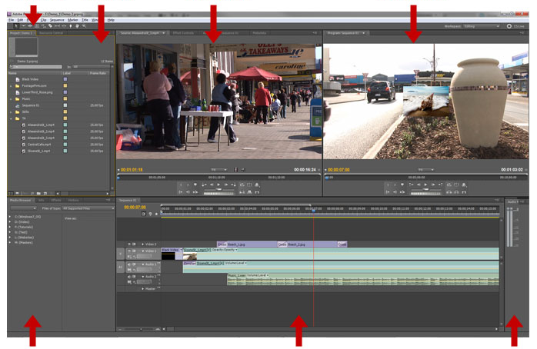

Tools Panel (label & description)
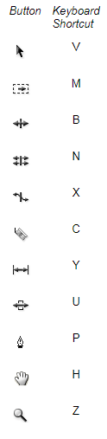
Project Panel (label)
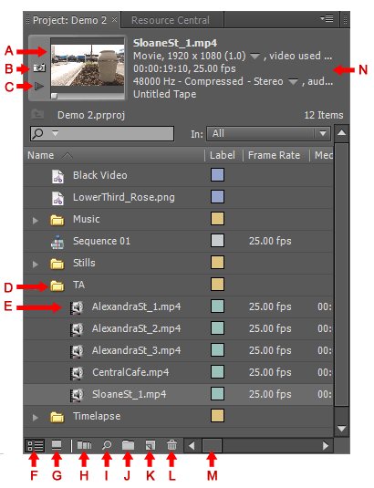
A
B
C
D
E
F
G
H
I
J
K
L
M
N
Monitor Panels (label & description)
A B
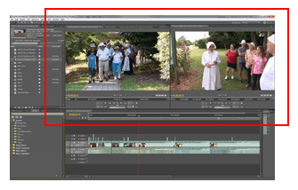
A

B

Timeline Panel (description)
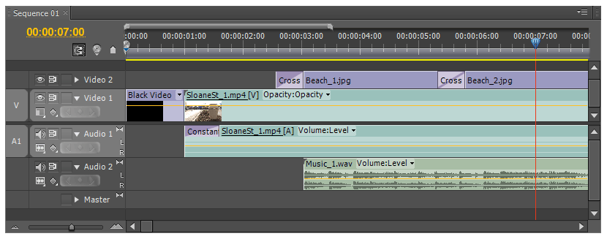
Current Timeline Indicator (description)
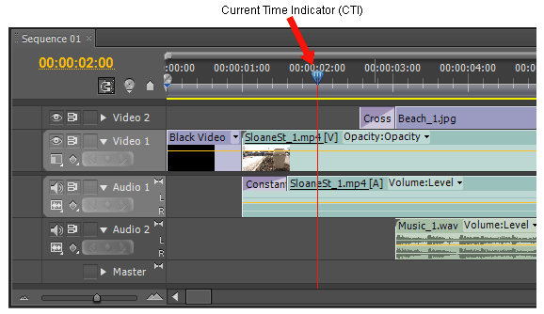
Other Common Panels (label & description)
